

ALGORITHM REGRESSION

**In this session**

* Regression Algorithms in Azure ML
* Create New ML Experiment
* Import auto data from UCI
* Add column name using python
* Clean missing data
* Select column (exclude column)
* Split data
* Add Linear Regression module
* Add Train Model
* Add Score Model
* Add Evaluate Model

Regression Algorithms in Azure ML

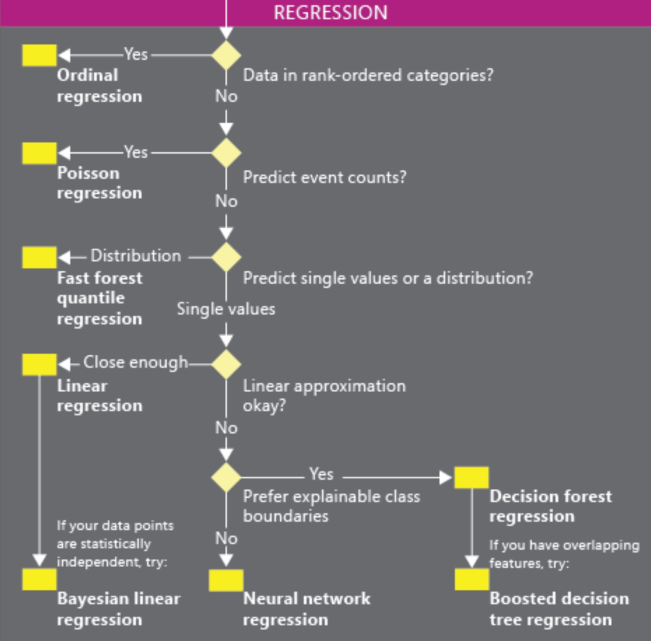

Over view

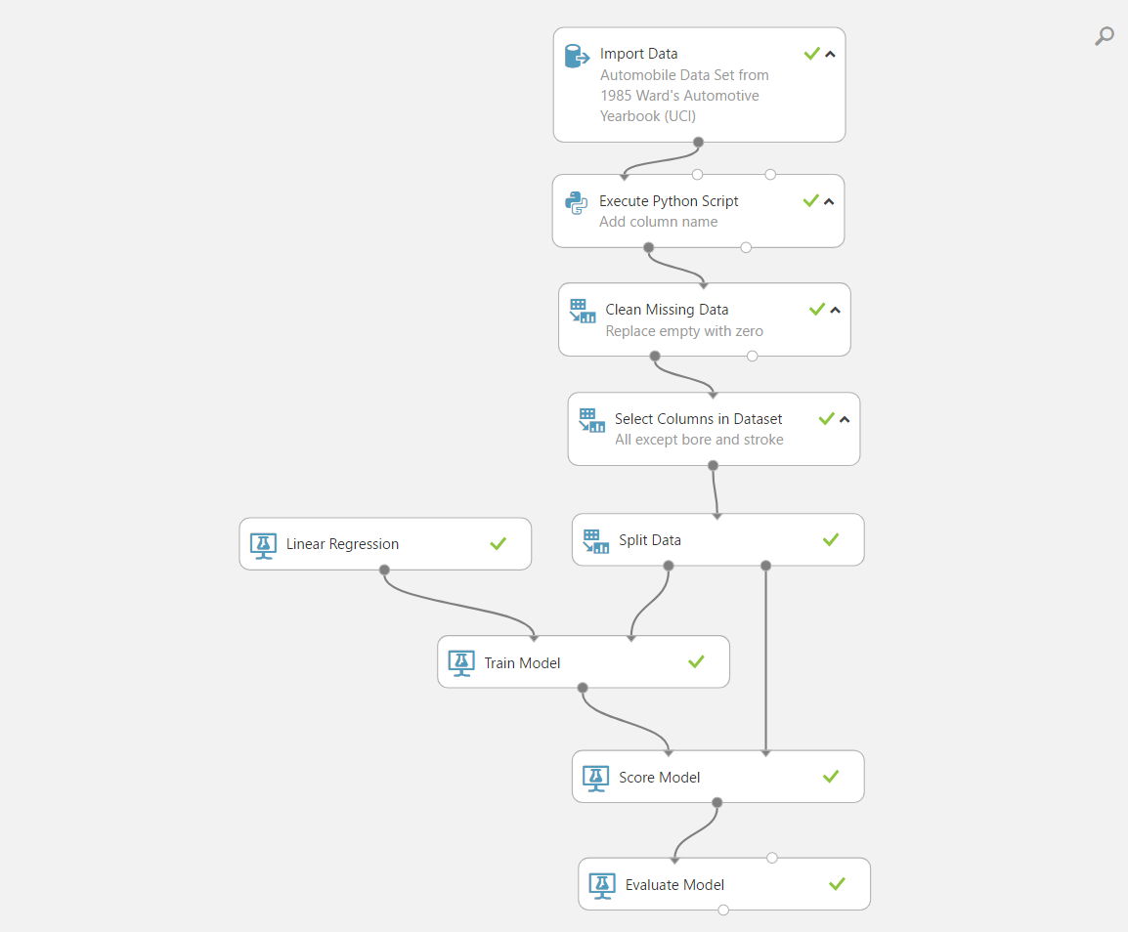

Working steps

Working Steps

1. Create New ML Experiment
2. Import auto data from UCI
3. Add column name using python
4. Clean missing data
5. Select column (exclude column)
6. Split data
7. Add Linear Regression module
8. Add Train Model
9. Add Score Model
10. Add Evaluate Model

Data set

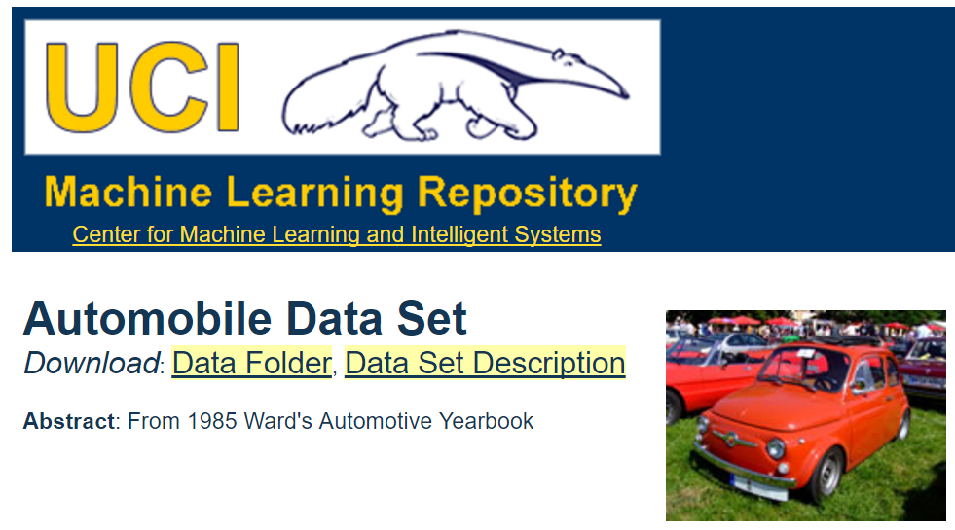

Home

<https://archive.ics.uci.edu/ml/datasets/Automobile>

Data download

<https://archive.ics.uci.edu/ml/machine-learning-databases/autos/imports-85.data>

Element column names/values

<https://archive.ics.uci.edu/ml/machine-learning-databases/autos/imports-85.names>

Data attribute

1. symboling: -3, -2, -1, 0, 1, 2, 3
2. normalized-losses: continuous from 65 to 256
3. make: alfa-romero, audi, bmw, chevrolet, dodge, honda, isuzu, jaguar, mazda, mercedes-benz, mercury, mitsubishi, nissan, peugot, plymouth, porsche, renault, saab, subaru, toyota, volkswagen, volvo
4. fuel-type: diesel, gas
5. aspiration: std, turbo
6. num-of-doors: four, two
7. body-style: hardtop, wagon, sedan, hatchback, convertible
8. drive-wheels: 4wd, fwd, rwd
9. engine-location: front, rear
10. wheel-base: continuous from 86.6 120.9
11. length: continuous from 141.1 to 208.1
12. width: continuous from 60.3 to 72.3
13. height: continuous from 47.8 to 59.8

Data attribute

1. curb-weight: continuous from 1488 to 4066
2. engine-type: dohc, dohcv, l, ohc, ohcf, ohcv, rotor
3. num-of-cylinders: eight, five, four, six, three, twelve, two
4. engine-size: continuous from 61 to 326
5. fuel-system: 1bbl, 2bbl, 4bbl, idi, mfi, mpfi, spdi, spfi
6. bore: continuous from 2.54 to 3.94
7. stroke: continuous from 2.07 to 4.17
8. compression-ratio: continuous from 7 to 23
9. horsepower: continuous from 48 to 288
10. peak-rpm: continuous from 4150 to 6600
11. city-mpg: continuous from 13 to 49
12. highway-mpg: continuous from 16 to 54
13. price: continuous from 5118 to 45400

Add column name Python Script

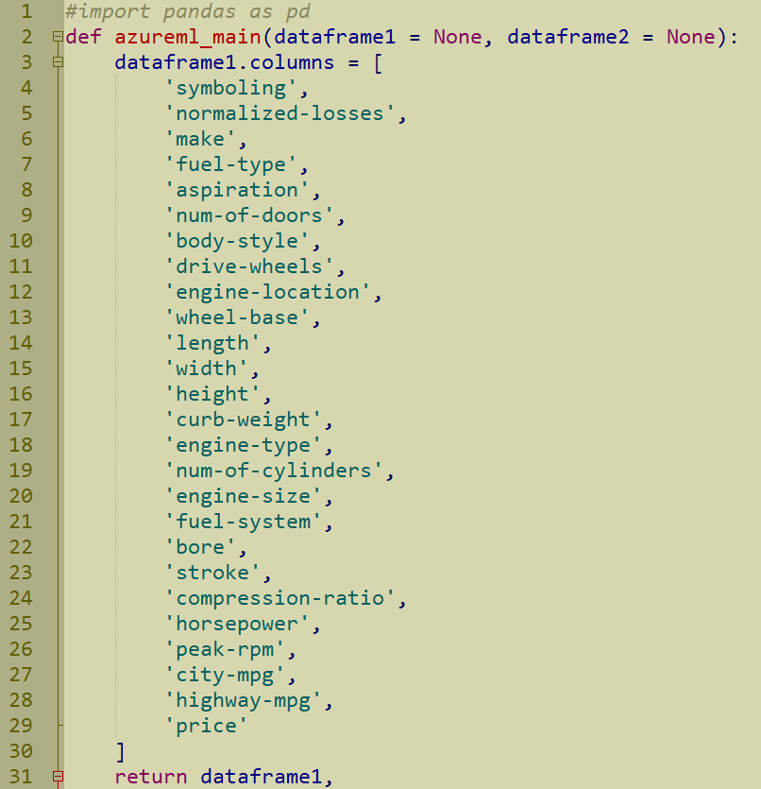

Clean missing data

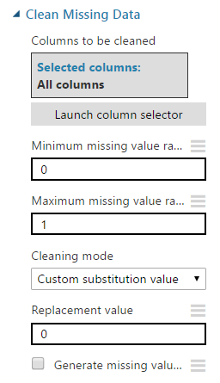

Select (exclude) column

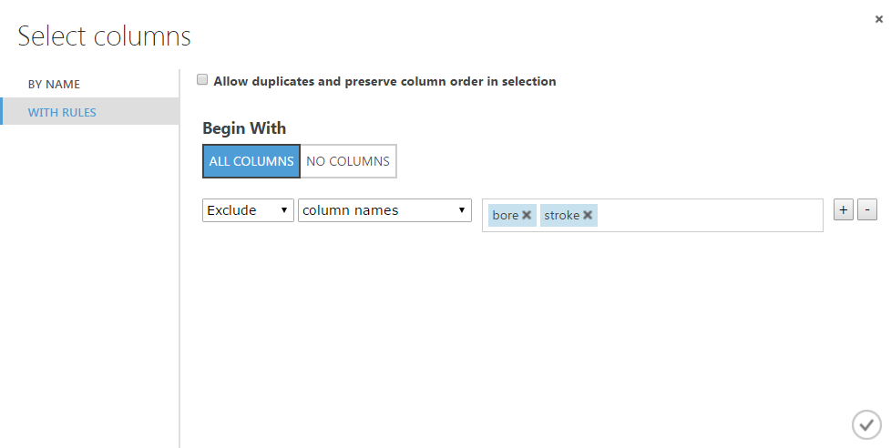

Split data

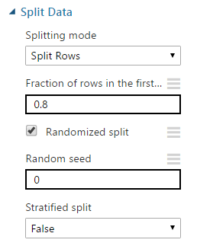

Evaluation Metrics

* Add Linear Regression module
* 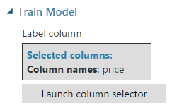Add Train Model
* Add Score Model
* Add Evaluate Model
* Run
* Inspect Score
* 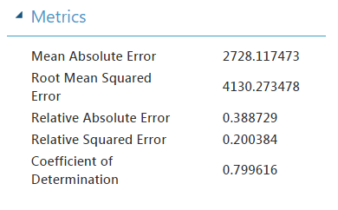Inspect Evaluate metrics

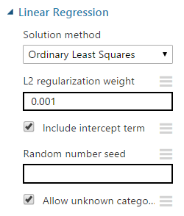

Regression compare

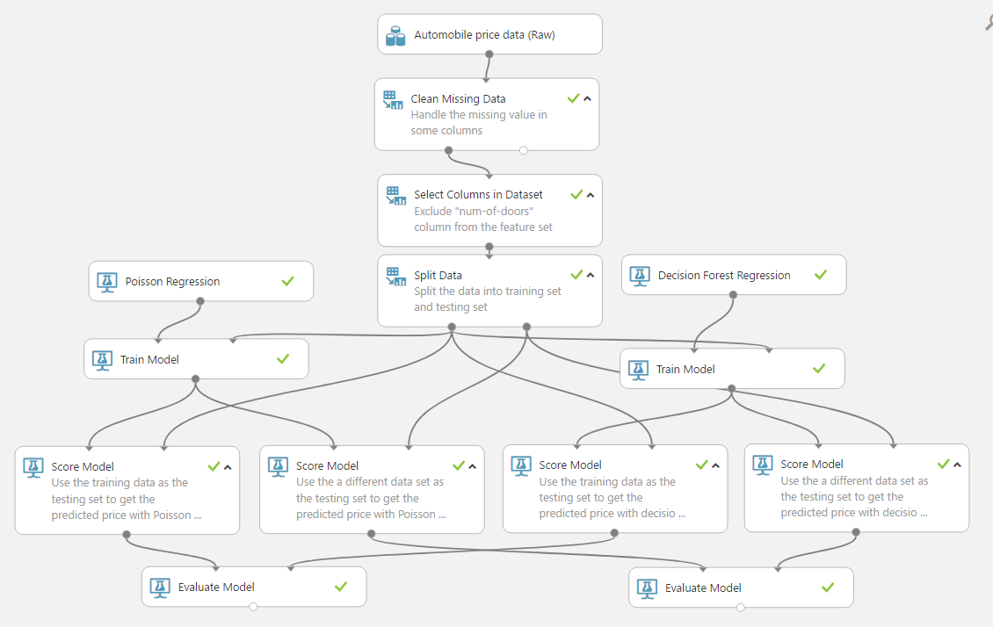

https://gallery.cortanaintelligence.com/Experiment/Regression-compare

Compare Decision Forest Regression with Poisson Regression

More information

Using linear regression in Azure Machine Learning

<https://docs.microsoft.com/en-us/azure/machine-learning/machine-learning-linear-regression-in-azure>

This Experiment

<https://gallery.cortanaintelligence.com/Experiment/Regression-3>

Regression compare

<https://gallery.cortanaintelligence.com/Experiment/Regression-compare>